Nacton Parish Council

Nacton Parish Councillors are summoned to a meeting of the Parish Council on Wednesday 10 January 2024 at Nacton Village Hall starting at 7:00pm

AGENDA

1. Apologies for absence

2. Declarations of interest
Councillors to declare if they have a pecuniary interest in any agenda
item.

3. Invitation to public to comment on agenda items

4. Minutes and actions of meetings
To agree on the minutes of the Meeting of the Parish Council held on 29
November 2023

5. Chairman’s update

6. Planning Applications

NEW:

Planning reference: DC/23/4256/FUL
Proposal: Erection of Storage Shed.
Site address: Broke Hall, Broke Hall Park, Nacton, Ipswich, Suffolk IP10 0ET
Consultation letter
expiry date: 15 January 2024

WAITING DECISION:

Ref. No: DC/23/4321/LBC | Validated: Wed 08 Nov 2023 | Status: Awaiting decision

Ref. No: DC/23/4320/FUL | Validated: Wed 08 Nov 2023 | Status: Awaiting decision

Ref. No: DC/23/3341/FUL | Validated: Fri 08 Sep 2023 | Status: Awaiting decision

7. Reports
7.1 –Suffolk County Council
7.2 - East Suffolk Council
7.3 - Village hall

8. Finances
8.1 - To agree the following payments to be made:

- Payments to Authorise:
- Village Hall Hire 29-Nov-23 = £35.00
- Village Hall Hire 10-Jan-24 = £35.00
- R. Warner expenses – petrol for grass cutting of Victoria Field (21-Jun-23 to 20-Nov-23) = £55.16
- Christmas Tree = £60.00
- Clerk Salary Feb-24 (£281.78) and Mar-24 (£281.78)
- RFO Salary Feb-24 (£94.50) and Mar-24 (£94.50)

Total £937.72

8.2 - Financial update from RFO to include:

- Balances on Current and Reserve Accounts
- Current position with CIL money reserve (CIL Return 2023 due 31st March 2024)
- Update on Bank Mandate signatures
- Online Banking new registrations ready for signing
- VAT reclaim processed for 1-Apr-23 to 30-Nov-23 (£151.33 received 21-Dec-23)
- Reminder for any expenses to be submitted ahead of Financial Year end (31st March 2024)

9. Parish documents
9.1 Emergency Plan
9.2 Maintenance Plan

10. Parish matters
10.1 Nacton Cricket Club proposal (playing field)
10.2 Grit bin
10.3 Parish matters arising
10.4 County Councillor

11. Matters raised by and reports by Councillors

12. Public question time

Copies of any briefing notes or draft documents issued to councillors will be held by the Clerk and are available to look at electronically. Details will also be available on the website http://nacton.suffolk.cloud/

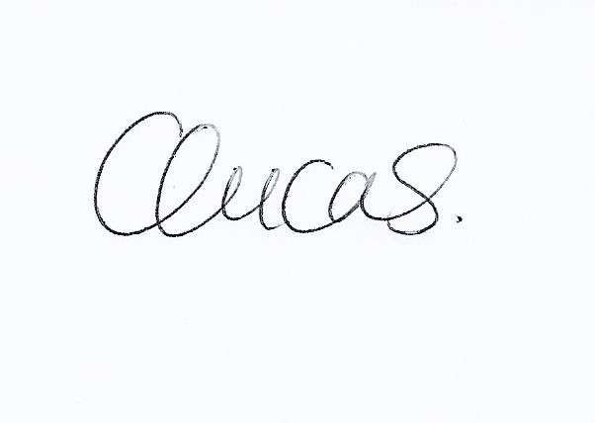

Clare Lucas.
Clerk to Nacton Parish Council

04 January 2024

