Nacton Parish Council

Nacton Parish Councillors are summoned to a meeting of the Parish Council on Wednesday 11th March 2026 at Nacton Village Hall starting at 7:00pm

AGENDA

NPC/25/70 Apologies for absence

NPC/25/71 Declarations of interest

Councillors to declare if they have a pecuniary interest in any agenda
item.

NPC/25/72 Invitation to public to comment on agenda items

NPC/25/73 Minutes and actions of meetings

To agree on the minutes of the Parish Council meeting held on 14 January 2026

NPC/25/74 Chairman’s update

NPC/25/75 Planning Applications

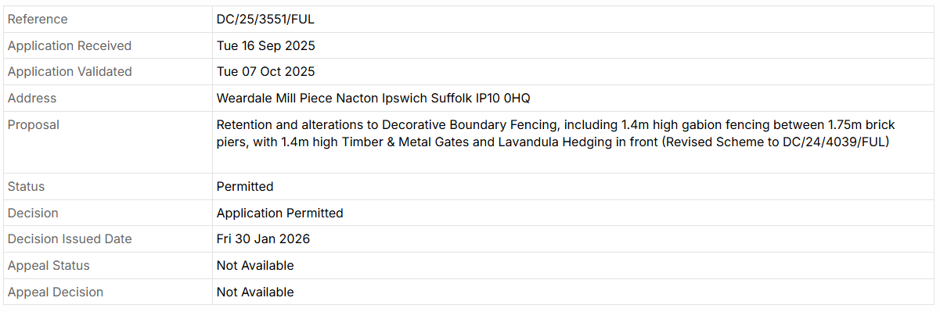

NPC/25/76 Reports

a –Suffolk County Council
b - East Suffolk Council
c - Village hall

NPC/25/77 Finances

- Financial update

NPC/25/78 Parish documents

- Emergency Plan
- Maintenance Plan
- Action Plan

NPC/25/79 Parish matters

- Local government review
- AGM & APM preparation
- Speed camera
- Survey
- Working groups
- War memorial
- Election 2027
- Litter pick
- Website
- Poors Field
- Tree Warden
- Pauper’s Wood
- Other parish matters arising
- Change of clerk

NPC/25/80 Matters raised by and reports by Councillors

NPC/25/81 Public question time

Copies of any briefing notes or draft documents issued to councillors will be held by the Clerk and are available to look at electronically. Details will also be available on the website https://nactonparishcouncil.gov.uk/

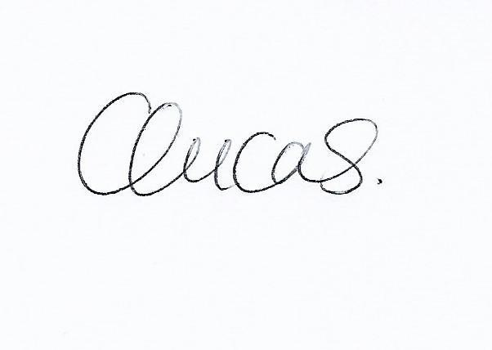
Clare Lucas.
Clerk to Nacton Parish Council

