Nacton Parish Council

Nacton Parish Councillors are summoned to a meeting of the Parish Council on Wednesday 14th January 202 at Nacton Village Hall starting at 7:00pm

AGENDA

NPC/25/53 Apologies for absence

NPC/25/54 Declarations of interest

Councillors to declare if they have a pecuniary interest in any agenda
item.

NPC/25/55 Invitation to public to comment on agenda items

NPC/25/56 Minutes and actions of meetings

To agree on the minutes of the Parish Council meeting held on 02 December 2025

NPC/25/57 Chairman’s update

NPC/25/58 Planning Applications

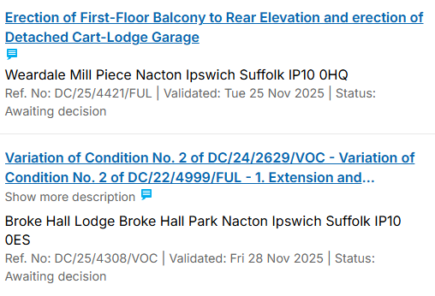
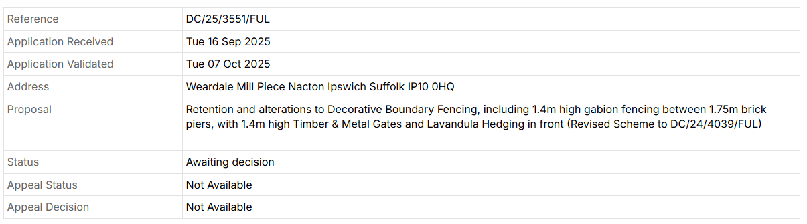

NPC/25/59 Highways Consultation SCC/0170/25SC A12 between Junctions 58 (Seven Hills) and Woods Lane Roundabout, Woodbridge

NPC/25/60 Reports

a –Suffolk County Council
b - East Suffolk Council
c - Village hall

NPC/25/61 Finances

- Financial update
- Precept

NPC/25/62 Parish documents

- Emergency Plan
- Maintenance Plan
- Action Plan
  - To discuss asking parishioners for their suggestions on ways to spend parish money

NPC/25/63 Parish matters

- Local government review
- Working groups
- Asset register
- Email database
- Website - updates to news section
- Poors Field
- Tree Warden
- Pauper’s Wood
- Other parish matters arising

NPC/25/64 Matters raised by and reports by Councillors

NPC/25/65 Resignation of the chairperson

NPC/25/66 Election of chairperson

NPC/25/67 Receive the chair person’s Declaration of Acceptance of Office
NPC/25/68 Election of Vice Chair person

NPC/25/69 Public question time

Copies of any briefing notes or draft documents issued to councillors will be held by the Clerk and are available to look at electronically. Details will also be available on the website http://nacton.suffolk.cloud/

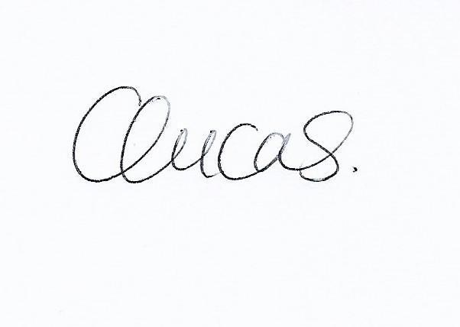
Clare Lucas.
Clerk to Nacton Parish Council

