Nacton Parish Council

Nacton Parish Councillors are summoned to a meeting of the Parish Council on Wednesday 25 September 2024 at Nacton Village Hall starting at 7:00pm

AGENDA

1. Apologies for absence

2. Declarations of interest
Councillors to declare if they have a pecuniary interest in any agenda
item.

3. Invitation to public to comment on agenda items

4. Minutes and actions of meetings
To agree on the minutes of the Meetings (APM and AGM) of the Parish Council held on 31 July 2024

5. Chairman’s update

6. Planning Applications

Consultations:

Planning reference: DC/24/3114/FUL
Proposal: Removal of old hedge which is in a very poor state and erection of new 2m

fence with new hedge in front to soften the impact.

Site address: Woodlands, Ipswich Road, Nacton, Ipswich, Suffolk IP10 0EG

Consultation letter

expiry date: 30 September 2024

Planning reference: DC/24/2986/ROC
Proposal: Removal of Condition No. 3 of C6346/1 - Erection of New Parsonage (to replace use of existing rectory) on Glebe Land adjoining rectory (OS Parcel 7100) Ipswich Road, Nacton. - Removal of Occupancy Condition.

Site address: The Rectory, Ipswich Road, Nacton, Ipswich, Suffolk IP10 0HY

Consultation letter

expiry date: 24 September 2024

Town and Country Planning Act 1990 - Appeal Under Section 78
Appeal by: P.L.O.T Community Interest Company

Site at: Land Adjacent Orwell Park Gardens, Church Road, Nacton,
Suffolk

Planning application reference: DC/24/0352/FUL

An appeal has been made to the Secretary of State by P.L.O.T Community Interest Company against the decision of East Suffolk Council* to refuse planning permission for Retrospective
application - A change of use from agricultural land to F1 for use by community interest company P.L.O.T.
.

PERMITTED:

Reference DC/24/2527/AME

Application Received Fri 12 Jul 2024
Application Validated Fri 12 Jul 2024

Address Weardale Mill Piece Nacton Ipswich Suffolk IP10 0HQ
Proposal Non Material Amendment of DC/23/3341/FUL - Site has current permission to convert & expand existing building under ref DC/20/3188/FUL.

This application is to utilise approved building footprint to create 1 no individual dwelling. - Gable roof element added to hipped roof to incorporate additional glazing to front elevation. PV Panel array added to roof on front elevation

Status Permitted
Decision Application Permitted
Decision Issued Date Tue 20 Aug 2024
Appeal Status Not Available
Appeal Decision Not Available

7. Reports
7.1 –Suffolk County Council
7.2 - East Suffolk Council
7.3 - Village hall

8. Finances

8.1 - To agree the following payments to be made:

- Payments to Authorise:
- Clerk Salary Oct-24 £286.65
- RFO Salary Oct-24 £96.12
- Village Hall Hire – Nov-24 £35.00
- Clerk Salary Nov-24 £286.65
- RFO Salary Nov-24 £96.12
- Contribution to Village Hall £600.00
- Contribution to Community Council £600.00
- Contribution to St. Martin’s Church £600.00

Total £2600.54

- Payments made since the last parish meeting:

01.08.24 | Clerk Expenses (Mileage) | 15.26
01.08.24 | Nacton Village Hall Hire - Parish Meeting | 35.00
22.08.24 | Victoria Field - fuel for grass cutting | 73.07
22.08.24 | Victoria Field - new Keys | 12.50
28.08.24 | Clerk Salary Aug-24 | 286.65
28.08.24 | RFO Salary Aug-24 | 96.12
04.09.24 | Owen Akers - Paupers Wood tree work | 100.00

Total £618.60

8.2 - Financial update from RFO to include:

- Bank Account balances
- Reserve account (savings options)
- CIL Update
- RFO to organise Finance Advisory Group meeting in November to draft Precept for 2025-26

9. Parish documents
9.1 Emergency Plan
9.2 Maintenance Plan
9.3 Action Plan

10. Parish matters
10.1 Mobile Signal Survey
10.2 Bus Shelter (In the Street)
10.3 Rural Coffee Caravan
10.4 Website and social media
10.5 Noticeboard outside the former shop
10.6 Other parish matters arising

11. Matters raised by and reports by Councillors

12. Public question time

Copies of any briefing notes or draft documents issued to councillors will be held by the Clerk and are available to look at electronically. Details will also be available on the website http://nacton.suffolk.cloud/

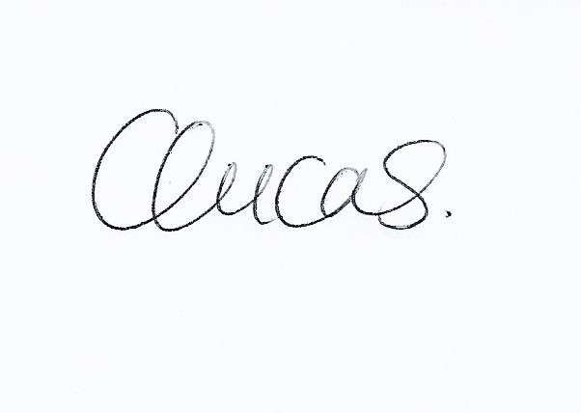

Clare Lucas.
Clerk to Nacton Parish Council

16 September 2024

