Nacton Parish Council

Nacton Parish Councillors are summoned to a meeting of the Parish Council on Wednesday 27 March 2024 at Nacton Village Hall starting at 7:00pm

AGENDA

1. Apologies for absence

2. Declarations of interest
Councillors to declare if they have a pecuniary interest in any agenda
item.

3. Invitation to public to comment on agenda items

4. Minutes and actions of meetings
To agree on the minutes of the Meeting of the Parish Council held on 10 January 2024

5. Chairman’s update

6. Planning Applications

WAITING DECISION:

Ref. No: DC/24/0352/FUL| Validated: Thu 08 Feb 2024| Status: Awaiting decision

Out of area but to discuss:

DC/24/0449/FUL Part Land At Foxburrow Farm Waldringfield Road Brightwell Change of use of land for the storage of containers (associated with Port of Felixstowe)

7. Reports
7.1 –Suffolk County Council
7.2 - East Suffolk Council
7.3 - Village hall

8. Finances

8.1 - To agree the following payments to be made:

- Payments to Authorise:
- Village Hall Hire 27-03-24 = £35.00
- Clerk Salary Apr-24 (£286.65) and May-24 (£286.65)
- Clerk expenses (mileage – 2 trips to the noticeboards) £10.17
- RFO Salary Apr-24 (£96.12) and May-24 (£96.12)

Total £810.71

- Payments made since last parish meeting:
- E Jacobs & Sons (village sign) £3,744.00 (authorised on emails 7-Mar-24)
- Kesgrave Aggregates (village sign base) £283.08 (previously agreed in Meeting)
- Seal Calibration (Defibrillator test) £154.80 (previously agreed in Meeting)
- Glasdon (2x grit bins) £431.33 (authorised on emails 31-Jan-24)
- Paul Tattersall (wine – thank you) £6.00 (de minimis value)

Total £4619.93

8.2 - Financial update from RFO to include:

- Bank Account balances and CIL reserve
- Feedback from Cllrs for new Online Banking registrations
- Clerk and RFO performance pay rises – approve and sign contract updates
- VAT Reclaim to 31-Mar-2024 – estimated £832.70
- Standing Order payments list (RFO sent update with Cash Book on 11th March 2024)
- Reminder – Year End Accounts close 31-Mar-24
- CIL Annual Report – RFO will prepare paperwork (post 31-Mar-24) and arrange signing

9. Parish documents
9.1 Emergency Plan
9.2 Maintenance Plan

10. Parish matters
10.1 Grit Bin
10.2 Village sign
10.3 Sizewell C update
10.4 Email from Matthew Hicks
10.5 Chairperson
10.6 Wooden Gate
10.7 Website and social media
10.8 Newsletter
10.9 Monkey challenge
10.10 Post van
10.11Other parish matters arising

11. Matters raised by and reports by Councillors

12. Public question time

Copies of any briefing notes or draft documents issued to councillors will be held by the Clerk and are available to look at electronically. Details will also be available on the website http://nacton.suffolk.cloud/

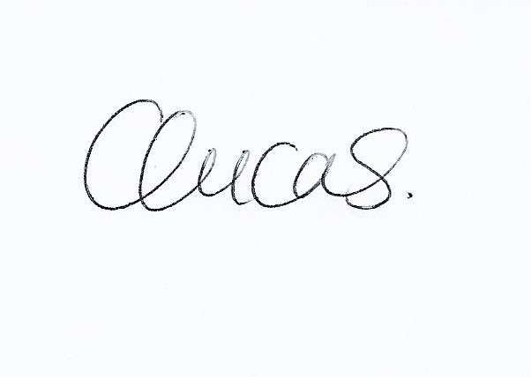

Clare Lucas.
Clerk to Nacton Parish Council

20 March 2024

