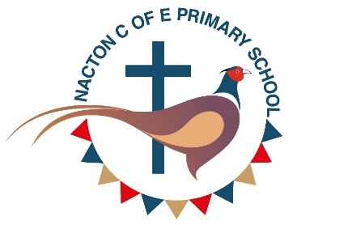
Report for annual meeting 2026
We are delighted to share that our school community continues to grow and thrive, and we have now reached 100 children on roll. This is a wonderful milestone for our school and reflects the strong support from families and the wider community.
This year, we have carefully reviewed our class organisation to ensure we continue to provide the very best learning experiences for our children. W reorganised our Early Years and Key Stage 1 provision to create a combined Reception and Year 1 class. This decision has been made thoughtfully and is rooted in our commitment to placing play-based learning at the heart of children’s development.
We strongly believe that young children learn best through exploration, curiosity and meaningful play experiences. Our aim is to nurture confident, curious learners who love learning and are excited to come to school each day. By extending opportunities for play-based learning into Year 1, we are creating an environment where children can develop independence, creativity, communication skills and a lifelong enthusiasm for learning.
To support this vision, we are very grateful to our Parent Teacher Association for kindly providing a brand-new play kitchen for the children. This has already become a much-loved addition to our learning environment and is helping to inspire imaginative and collaborative play.
Our PTA continues to work tirelessly to support the school through fundraising and community events. Recent school discos have been extremely successful and enjoyed by the children, while also raising valuable funds for school resources and experiences. We are also looking forward to hosting a Colour Run later this week, which promises to be a fun event for pupils and families alike.
We are also very proud to have recently received an excellent SIAMS inspection report, which highlighted the warm, inclusive nature of our school community. The report recognised the strong relationships across the school, the care shown to every child and the way our Christian vision supports all members of the school community to flourish.
Looking ahead, we are excited to announce that Forest School sessions will begin in September. This new initiative will provide children with regular outdoor learning opportunities, helping them to build confidence, resilience, teamwork and a deeper connection with the natural environment.
We would like to thank the Parish Council and the wider community for their continued support of our school. We are proud of the positive direction our school is taking and look forward to sharing further developments in the future.
Gemma Taylor
Headteacher

